Catholic Engaged Encounter Reservation
Please print clearly and complete the back side also.
Man’s Information
Last Name __________________________________
First Name
For name tag ____________________________
For certificate____________________________
Address _____________________________________
City/State/Zip ________________________________
Email Address: ______________________________
_{(circle one)}
Phone (_____) ______-________ Home Work Cell
Age _______ Religion _______________________
Woman’s Information
Last Name __________________________________
First Name
For name tag _____________________________
Cut here
For certificate_____________________________
Address ____________________________________
City/State/Zip _______________________________
Email Address: ______________________________
_{(circle one)}
Phone (_____) _____-________ Home Work Cell
Age _______ Religion _______________________
Support Contact: If possible, please give us a name of a friend or family member who supports and prays for the success of your marriage. We may contact them for prayer support.
For the Man: _______________________________
_{(circle one)}
Phone (_____) _____-______ Home Work Cell
Email Address: ___________________________
For the Woman: ____________________________
_{(circle one)}
Phone (_____) _____-_______ Home Work Cell
Email Address: ____________________________
How to Register:
By mail using the attached form
By Website: https://dioceseofgallup.org/
ministries/engaged-encounter
Early registrations are encouraged.
Checks or money orders should be made payable to “Catholic Engaged Encounter.”
If the payment is a financial hardship, please contact us. Full refunds will be made if a couple must cancel, up to five days prior to the weekend.

Pandemic Concerns: The retreat center is spacious and will accommodate the event without crowding. Safe distancing, masks and other precautions will be used as per current advice of health authorities to protect participants and staff.

Comments by
Past Participants:

The weekend –
---“helped our communication skills,
goals and priorities in life”
---“gave us a deeper sense of
commitment.”
---“put a whole different perspective on
marriage.”
---“helped us build the habit of
discussing sensitive things.”
---“was a very exciting and rewarding
time with each other away from
everyday life.”

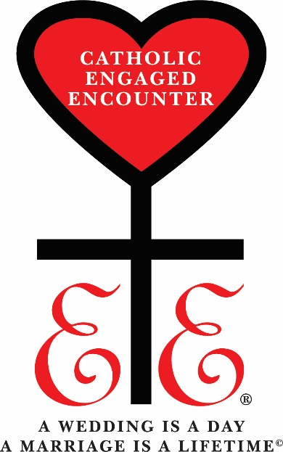

Catholic
Engaged Encounter
for the Diocese of Gallup

2022 Dates
March 5 - 6
June 11 - 12
November 5 - 6

What is Engaged Encounter?
The Catholic Engaged Encounter is a weekend event that challenges the participants to focus on their relationship as a couple and to talk honestly and intensively about their future together. It provides an atmosphere free of the tensions, pressures and interruptions of daily life.
The principal activity is a series of presentations by team couples addressing many aspects of marriage. The engaged couple is encouraged to reflect and then talk privately with each other. The topics focus on issues pertinent to forming a lasting and joy-filled marriage. Other activities include several spiritual and interactive events.

Who should attend?
The event is primarily designed to prepare a Catholic couple for marriage, but it is suitable for a woman and a man of any faith preparing for marriage who desire a deeper understanding of themselves and the abundant life of a faith-filled marriage. The retreat adheres to the teachings of the Catholic Church, particularly that marriage is sacramental. Catholic couples are reminded to contact their parish pastor as early as possible to begin the required preparation process. The couples who attend this weekend more than two months prior to their wedding obtain the maximum benefit. Couples from a wide variety of circumstances find the weekend rewarding, even those who have long-term relationships in a civil union.
Where is the Encounter Held?
Sacred Heart Retreat Center in Gallup, New Mexico. Directions will be mailed to each registrant. Men and women are housed in separate areas. Attendees who have local lodging arrangement may commute to the event if they prefer.
What is the Cost?
Regular Fee - $85 per couple
includes lodging, (1 or 2 nights)
material, and meals
Commuter Fee - $50.00 per couple.
materials and meals only
Schedule?
Saturday: 8:00 AM to 10:00 PM
Sunday: 8:00 AM to 4:00 PM
Couples lodging at the retreat center may stay both Friday and Saturday nights, or just Saturday night. Friday check-in is 7:00 – 9:00 PM.
If you have questions
See the Website (front side)
or the contacts below:
Maria & Randy Copeland
Phone: (505) 726-2707
Email: gallup@engagedencounter.com

Other Opportunities
Please call for more information or view on the Internet at:
www.engagedencounter.org/

[Reservation – continued from other side]

Parish to be married in:
City: ___________________________________
Wedding Date: __________________________
Priest or Pastor’s Name
_______________________________________
Referred to Engaged Encounter by:
_______________________________________

Contact after the wedding:
Address ________________________________
City/State/Zip___________________________
Phone ( ) _______-___________

Desired Catholic Engaged Encounter Weekend:
(circle choice) March 5 - 6
Cut here
June 11 - 12
November 5 - 6
Special Needs: (dietary, physical impairments, or
medical issues that require accommodations)
___________________________________
Registration Fee – (select one)
Regular: $ 85.00 per couple (meals & lodging)
Commuter: $ 50.00 per couple (meals only)

*** Please make check payable to:
Catholic Engaged Encounter
Mail To: Catholic Engaged Encounter
1609 Redrock Dr.
Gallup, NM 87301

