CREATING YOUR OWN ACCOUNT:
ONLINE COURSES, WORKSHOPS, AND WEBINARS
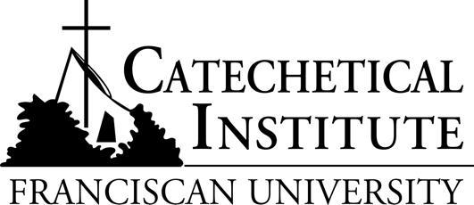

- Online, search: franciscanathome.org
- On top center of home page, click on Partnering Dioceses
Scroll down to, and click on, DIOCESE OF GALLUP.
- On Diocese of Gallup page, read Bishop Wall’s message to participants,
- On the left, note the learning tracks designed for our Diocesan members.
- On the right, click on the second blue block to register online through your parish.
- On the “Sign Up for Free through Your Institution” page, find the third drop-down list of parishes and choose yours and click on it.
- When the green button appears, click on it and it will lead you to the registration form.
- After filling in the form, proceed, and you will find this message on your ‘Dashboard:’
CONGRATULATIONS!! You have successfully received a free subscription to Franciscan at Home through your institution!
Here, on your Dashboard, you can view available learning tracks and individual workshops.

On the left-hand side of the Dashboard the Institutional Tracks are those that Officials have chosen for specific ministers in our Diocese.

Below them are the Franciscan Tracks prepared by the Catechetical Institute for types of ministers in any parish setting. https://franciscanathome.com/tracks-and-workshops N.B. Follow this link to an explanation of the Ongoing Diaconal Formation Track.
On the right-hand side of the Dashboard, you will be able to search for topics that interest you or for presenters that you may already know about. These works may be in the form of either workshops, webinars, or seminars. Some are just for listening!
‘Forming those who form others’ is the purpose of the Catechetical Institute!

When you want to begin an established workshop of courses, you have a choice: you can select the Catechist Formation Track prepared by the Diocese, OR the Catechist (CT) Track prepared by the Catechetical Institute. N.B.: The Diaconate Ongoing Formation Track is prepared by the Catechetical Institute of Franciscan University of Steubenville, OH. Your certificate of completion will come, through the Diocesan Office, with credits for the Track that you choose to do.

Depending on the Course that you choose, you will see either the box “Request A Mentor” (to select someone from the Catechetical Institute or from your parish or diocese)
OR
you will see “Send/Save Paperwork” and you can select Sr. Carol as the one to ‘send’ your typed-in answers and comments online to her or let the work that you do remain on the website until you are finished.

Our recent speaker, Dr. William Keimig, D. Min., Director of the Catechetical Institute, encouraged both Deacons, and Catechists alike, to proceed in this formation opportunity in small groups. Working on these topics together can help us to get to know each other better, increase collaboration among us, and strengthen our witness in our parishes. Such collaboration could be either online or in person.

If you have any questions or need assistance to determine your way forward, please contact me at religiouseducation@dioceseofgallup.org

Sister Carol Woods, sfma
Franciscan Missionary Sisters of Assisi

Director of Religious Education
Diocese of Gallup, NM
Office at Chancery: (505)-863-4406 (ext. 1022)

